Week 04 - DigiDev-F18 – Homework – John Krahenbuhl

**Short Wish List**



Light to Frequency Converter - TSL235R ($2.95)

<https://www.sparkfun.com/products/9768>

Note: Outputs a square wave (50% duty cycle) with frequency directly proportional to light intensity (irradiance). No external components are necessary to use the converter, and the digital output allows direct interface to a microcontroller or other logic circuitry.



Raspberry Pi NoIR Camera Board v2 - 8 Megapixels PRODUCT ID: 3100 ($29.95)

<https://www.adafruit.com/product/3100>

Note: attaches to the Pi by way of one of the small sockets on the board's upper surface and uses the dedicated CSi interface, designed especially for interfacing to cameras.

Adafruit Raspberry Pi Camera Board Case with 1/4" Tripod Mount PRODUCT ID: 3253 ($2.95)

<https://www.adafruit.com/product/3253>



Kuman for Raspberry PI Camera Module 5MP 1080p OV5647 Sensor HD Video Webcam Night Vision for All Vision Raspberry Pi model B/B+ A+ RPi 3/2/1 SC15-1 ($23.99)

<http://www.kumantech.com/kuman-for-raspberry-pi-camera-module-5mp-1080p-ov5647-sensor-hd-video-webcam-night-vision-for-all-vision-raspberry-pi-model-b-b-a-rpi-3-2-1-sc15-1_p0432.html>



DepthEye 3D visual TOF Depth Camera ($99.00)

<https://www.seeedstudio.com/DepthEye-3D-visual-TOF--Depth-Camera-p-3025.html>

Note: USB Micro B connection



 PureThermal 2 - FLIR Lepton Smart I/O Board (needs module) ($239.95)

<https://www.sparkfun.com/products/14670>

Note: to read an image from the lepton module all you need is an SPI port, and to configure the camera settings you also need an I2C port, although this is not required.

FLIR Radiometric Lepton Dev Kit

<https://www.sparkfun.com/products/14654>

GetThermal Library:

<https://github.com/groupgets/GetThermal>



SparkFun Current Sensor Breakout - ACS723 ($7.95 – Backordered)

<https://www.sparkfun.com/products/13679>

Current Sensor Breakout (ACS723) Hookup Guide

<https://learn.sparkfun.com/tutorials/current-sensor-breakout-acs723-hookup-guide>

Note: Hook up to am Analog Pin to read Voltage output proportional to current flowing through IP+ and IP-



[SparkFun Adjustable LiPo Charger](https://www.sparkfun.com/products/14380) ($10.95)

[Only 14 left!](https://learn.sparkfun.com/static/bubbles/) PRT-14380

<https://www.sparkfun.com/products/14380?_ga=2.134316785.1067252042.1537283322-530044998.1535318770>

Adjustable LiPo Charger Hookup Guide

<https://learn.sparkfun.com/tutorials/adjustable-lipo-charger-hookup-guide>

Note: Stand Alone Unit



OpenMV M7 Camera ($65.00)

<https://www.sparkfun.com/products/14632>

Note: The OpenMV can be programmed in high-level Python scripts (courtesy of the MicroPython Operating System) instead of C/C++. This makes it easier to deal with the complex outputs of machine vision algorithms and working with high-level data structures. You still have total control over your OpenMV M7 and its I/O pins in Python. You can easily trigger taking pictures and video on external events or execute machine vision algorithms to figure out how to control your I/O pins.

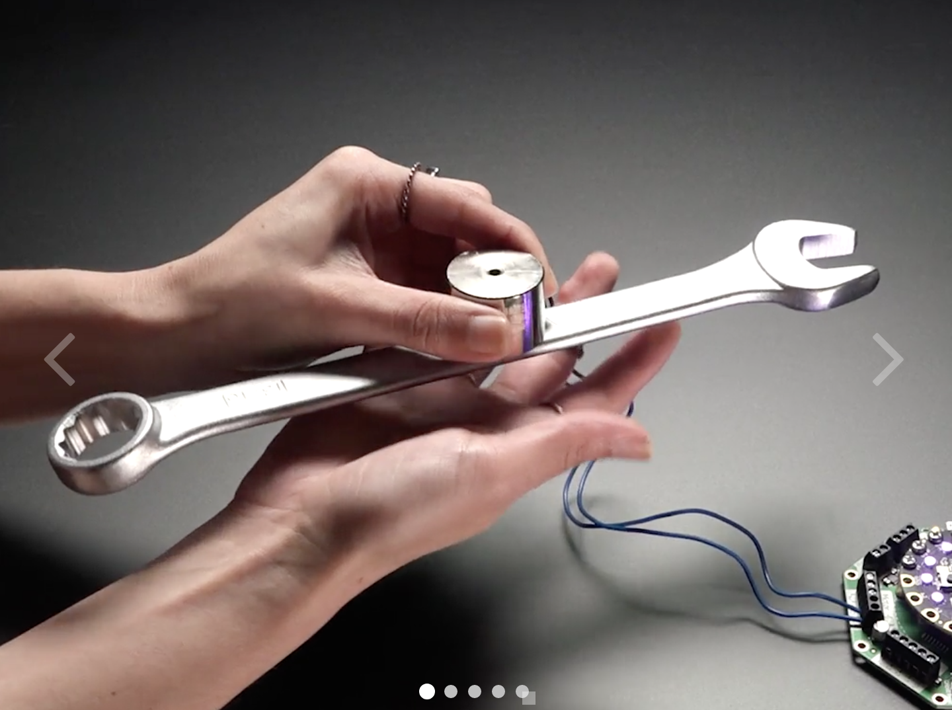

# **5V Electromagnet - 10 Kg Holding Force - P30/22 ($14.95)**

<https://www.adafruit.com/product/3874>

Note: What this means is that you just need to power this here electromagnet with about 5VDC (you don't have to be exact, 4-6V will work fine) and ka-pow, it's now a magnet. Turn off the power and it reverts back to a normal chunk of metal. Since its a coil, you'll need to use a motor or solenoid driver with kick-back protection.

Need this too:

Adafruit CRICKIT for Circuit Playground Express PRODUCT ID: 3093 ($29.95 – Out of Stock)

<https://www.adafruit.com/product/3093>



# **Bone Conductor Transducer with Wires - 8 Ohm 1 Watt** PRODUCT ID: 1674 **($8.95)**

<https://www.adafruit.com/product/1674>



# **CMOS Camera Module - 728x488 ($31.95)**

[16 available](https://www.sparkfun.com/static/bubbles/) SEN-11745 [ROHS](https://www.sparkfun.com/static/rohs/)

<https://www.sparkfun.com/products/11745>

Note: operating voltage (6V to 20V) – RCA Output

Smallest 3D depth sensing camera module worldwide!

<https://www.pmdtec.com/news_media/video/3d-depth-sensing.php>